暨南大学本科实验报告专用纸

课程名称 数值计算实验 成绩评定
实验项目名称 PageRank problem 指导教师 Liangda Fang
实验项目编号 04 实验项目类型 综合型 实验地点 N116
学生姓名 蒋云翔 学号 2022102330
学院 国际学院 系 计算机系 专业 CST
实验时间2024年 11 月 29 日上午10:30～ 12:10

Ⅰ. Problems
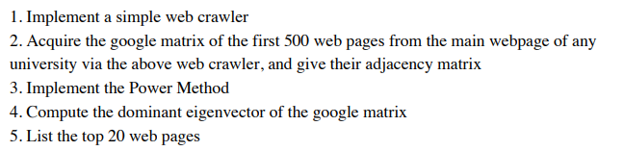

Ⅱ. Algorithm summary
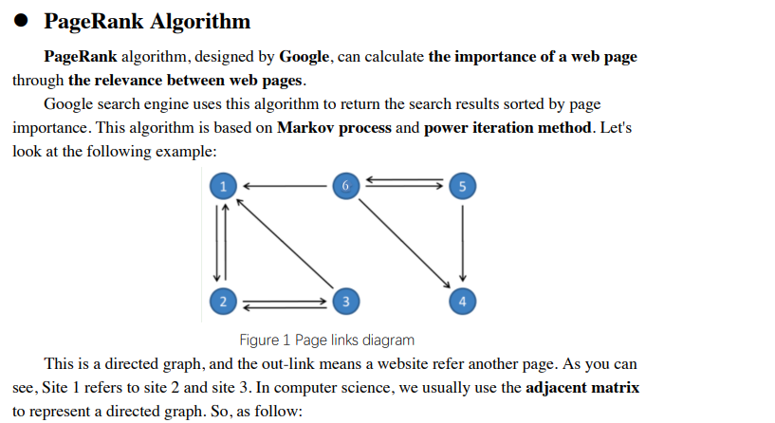

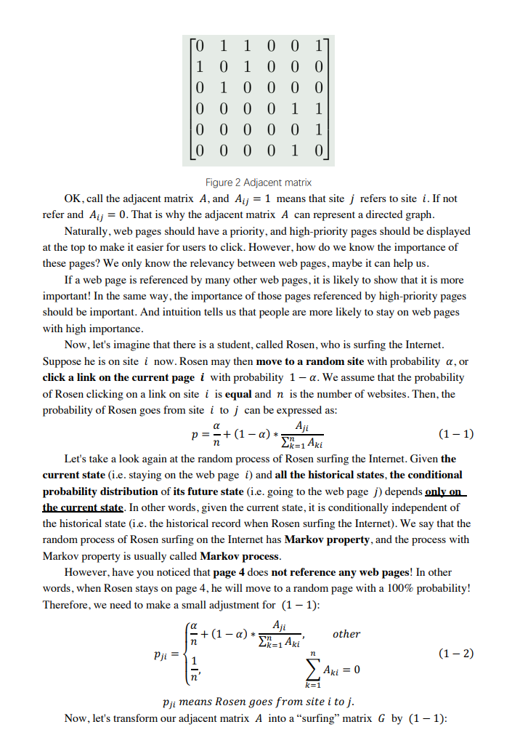

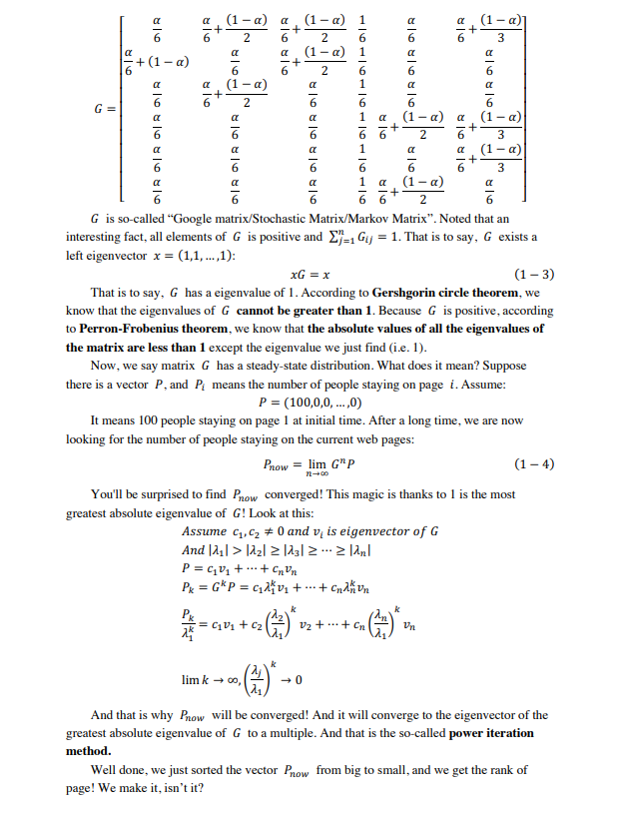

Ⅲ. Result analysis
Crawling websites:
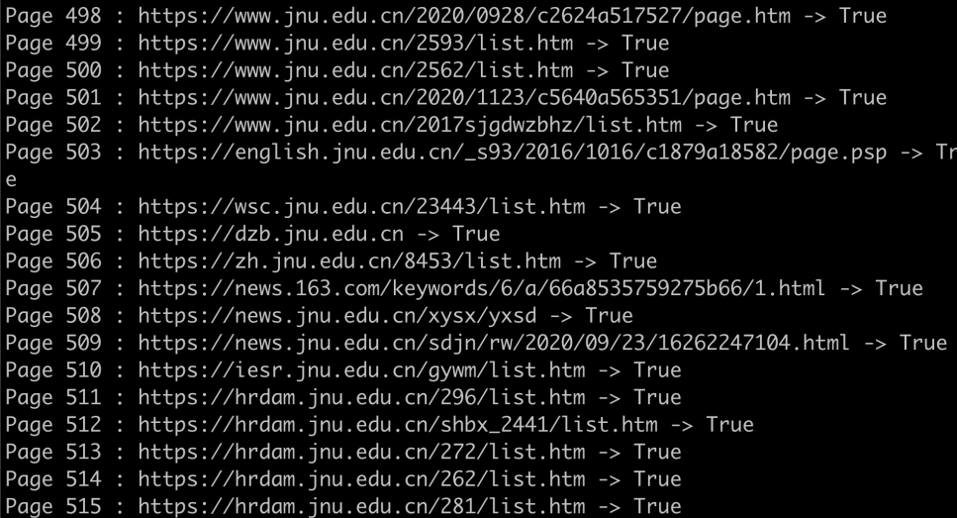
The 500 pages adjacent matrix:
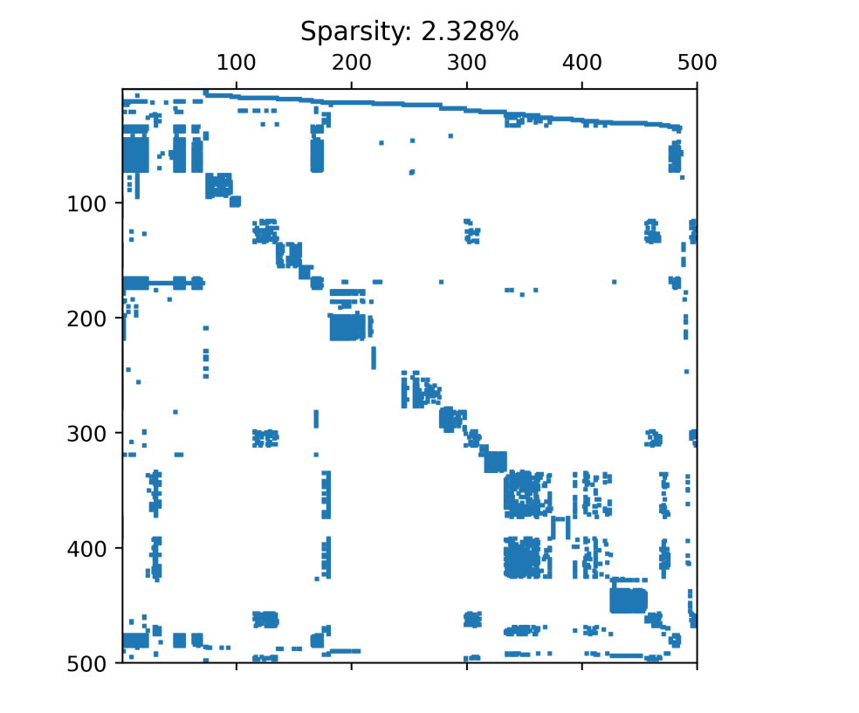

The top 20 web pages:
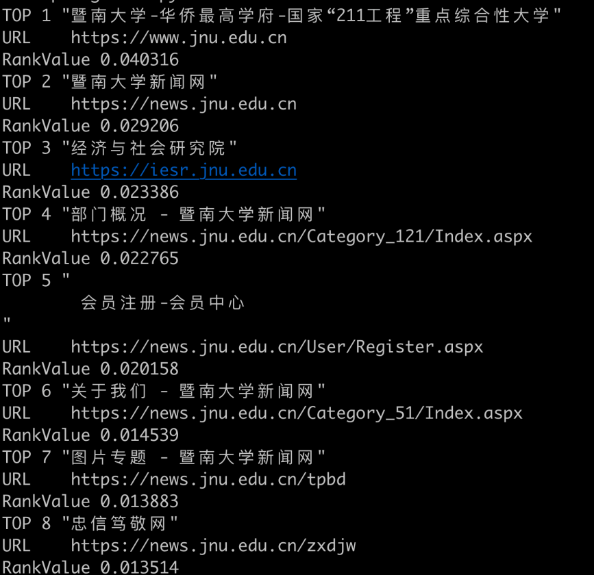
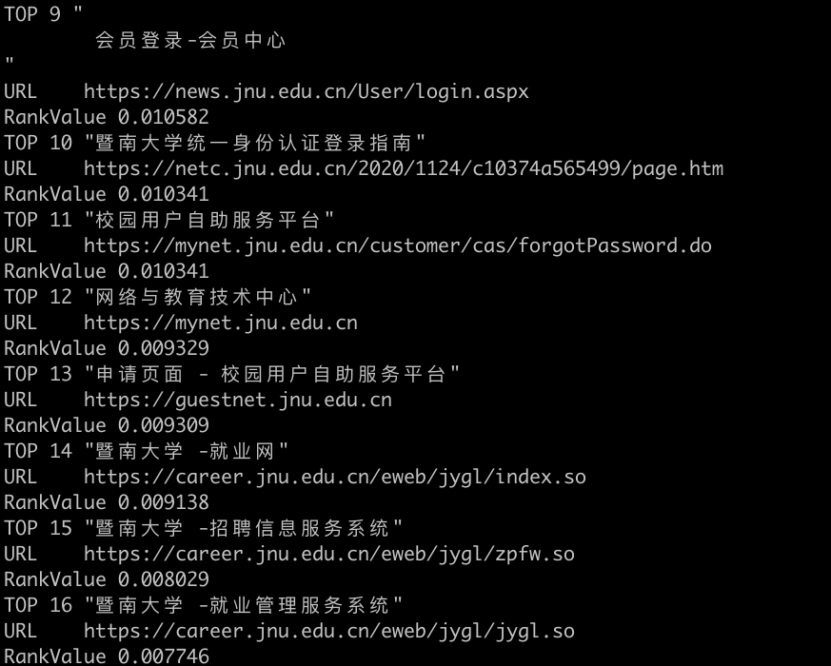
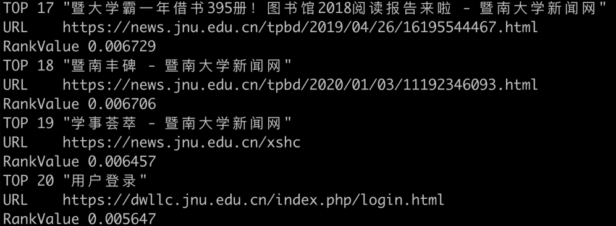
Website rank value distribution:
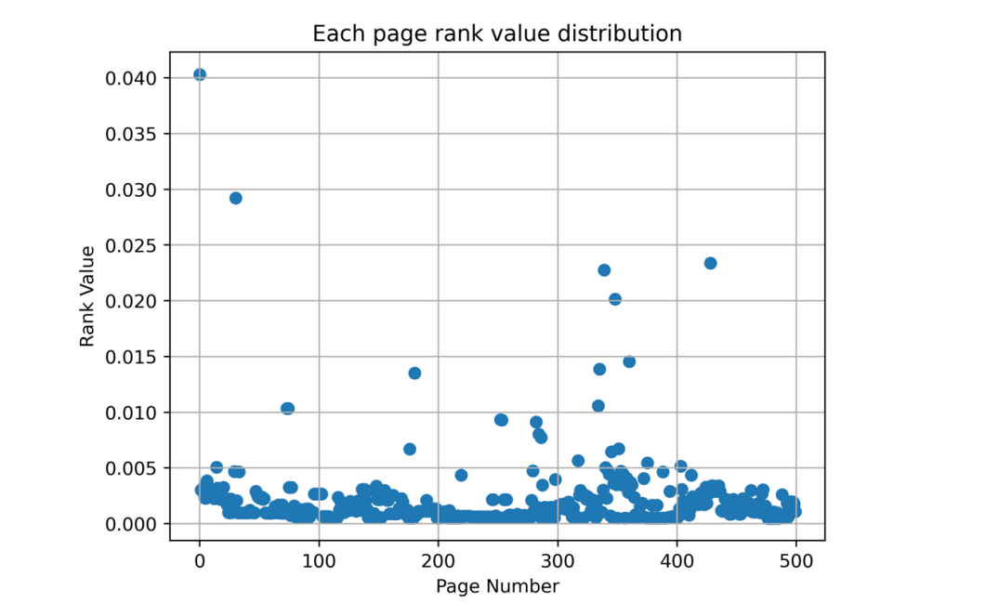

Ⅳ. Experimental summary
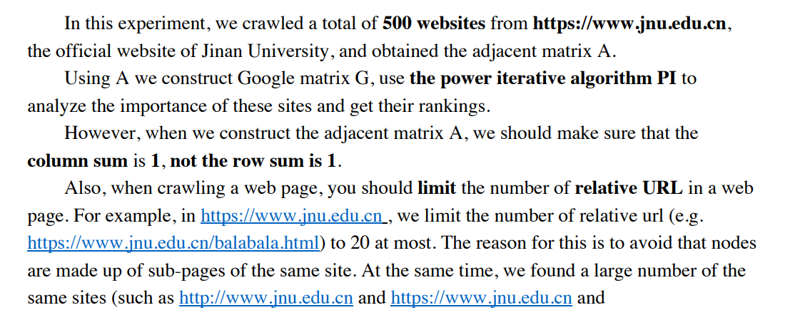
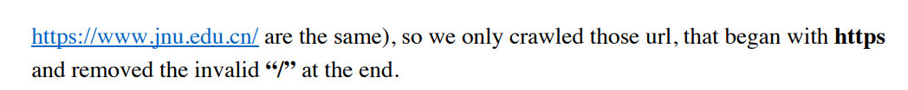

Ⅴ、Appendix: Source code
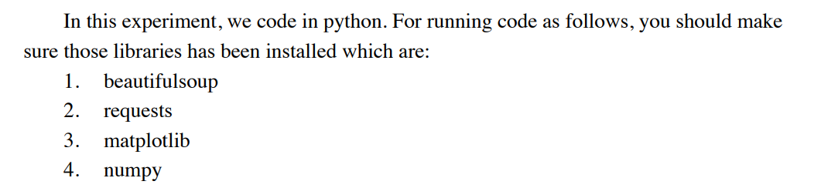

Crawler.py
from requests import get, head
from bs4 import BeautifulSoup
from random import sample
from urllib.parse import urljoin
from time import sleep
# 设置每个节点至多出边、节点总数
NUM_SITE_LIM = 500
RELATIVE_OUTLINKS_LIM = 20
class Crawler:
headers = {
'Mozilla/5.0 (Windows NT 10.0; Win64; x64) AppleWebKit/537.36 (KHTML, like Gecko) Chrome/131.0.0.0 Safari/537.36 Edg/131.0.0.0'
}
num_site = 0 # 已爬取网站个数
crawling = [] # 待爬池
checked = set() # 已爬池
unreachable_site = set() # 坏节点池
link_graph = {} # 网站连接图
def __init__(self, baseURL, verbose):
# verbose 为 True 时，打印debug信息
self.crawling.append(baseURL)
self.num_site = self.num_site + 1
self.verbose = verbose
def extractOutLink(self, url):
try:
response = head(url)
if 'text/html' not in response.headers['content-type']:
raise Exception
response = get(url, headers=self.headers, timeout=10)
except:
# 网站在指定时间到不了，或者url不是返回html
self.checked.remove(url)
self.unreachable_site.add(url)
self.num_site = self.num_site - 1
return False
# 设置为utf-8，否则中文乱码
response.encoding = 'utf-8'
soup = BeautifulSoup(response.text, 'lxml')
# 这里保证outlinks是绝对url
# 并且限制相对url的数目（避免太多非首页的url）
# 并且只爬https
outlinks = soup.find_all('a', href=True)
relative_urls = [url['href'] for url in outlinks if url['href'].startswith('/')]
absolute_urls = [url['href'] for url in outlinks if url['href'].startswith('https')]
relative_urls = sample(relative_urls, min(len(relative_urls), RELATIVE_OUTLINKS_LIM))
absolute_urls = absolute_urls + [urljoin(url, outlink) for outlink in relative_urls]
outlinks = absolute_urls
# 去除link后无效的'/'
outlinks = [outlink[:-1] if outlink.endswith('/') else outlink for outlink in outlinks ]
for outlink in outlinks:
if outlink not in self.crawling and \
outlink not in self.checked and \
outlink not in self.unreachable_site and \
self.num_site < NUM_SITE_LIM:
self.crawling.append(outlink)
self.num_site = self.num_site + 1
self.link_graph[url] = outlinks
response.close()
return True
def run(self):
print('ip被封，shit')
index = 1
while self.crawling:
url = self.crawling.pop(0)
self.checked.add(url)
status = self.extractOutLink(url)
if self.verbose:
print('Page', index,':', url, '->', status)
index = index + 1
if self.verbose:
print('Hah, we make it! Total numbers of site:', self.num_site)
print('keys:', len(self.link_graph.keys()))
def getAdjacentMatrix(self):
# 从有向图转成相邻矩阵
keys = tuple(self.link_graph.keys())
for key in keys:
for site in self.link_graph[key]:
if site not in keys or site == key:
self.link_graph[key] = [x for x in self.link_graph[key] if x != site]
M = [ [0]*self.num_site for i in range(self.num_site) ]
for site, outlinks in self.link_graph.items():
i = keys.index(site)
for outlink in outlinks:
j = keys.index(outlink)
M[i][j] = 1
return M
def getUrlTitle(url):
# 返回对应 URL 的 <title>
headers = {
'Mozilla/5.0 (Windows NT 10.0; Win64; x64) AppleWebKit/537.36 (KHTML, like Gecko) Chrome/131.0.0.0 Safari/537.36 Edg/131.0.0.0'
}
response = get(url, headers=headers)
response.encoding = 'utf-8'
soup = BeautifulSoup(response.text, 'lxml')
response.close()
return soup.find('title').text

PowerIteration.py
import numpy as np
alpha = 0.15
def power_iteration(M):
n = M.shape[0]
# x0 = [1 0 0 ... 0]
x = [0 for i in range(n)]
x[0] = 1
x = np.array(x)
# e = [1 1 ... 1]
e = np.array([1 for i in range(n)])
# 常规解法
while True:
x_new = np.dot(M,x)
dist = np.linalg.norm(x_new - x)
if dist < 1e-20:
break
else:
x = x_new
return x_new

PageRank.py
from Crawler import Crawler, getUrlTitle
from PowerIteration import power_iteration
from FigGen import gen_result_fig, gen_sparse_fig
from os.path import exists
from json import dump, load
from datetime import datetime
import numpy as np
if not exists('data.json'):
crawler = Crawler(
baseURL='https://www.jnu.edu.cn',
verbose=True # False则不显示debug信息
)
start = datetime.now()
crawler.run()
end = datetime.now()
gap = end - start
print('网站爬取用时:', gap.total_seconds(), '秒')
data = dict()
data['adjacent_matrix'] = crawler.getAdjacentMatrix()
data['directed_graph'] = crawler.link_graph
data['num_site'] = crawler.num_site
with open('data.json', 'w', encoding='utf-8') as f:
dump(data, f, ensure_ascii=False, indent=4)
with open('data.json', 'r') as f:
data = load(f)
M = data.get('adjacent_matrix')
G = data.get('directed_graph')
num_site = data.get('num_site')
alpha = 0.15
gen_sparse_fig(M, filename='Assets/adjacent_matrix.png') # 绘制稀疏矩阵
# 相邻矩阵M to Google矩阵M
for row in range(num_site):
row_sum = sum(M[row])
if row_sum == 0:
for col in range(num_site):
M[row][col] = 1 / num_site
else:
for col in range(num_site):
random_surf = alpha * (1 / num_site)
outlink_surf = (1 - alpha) * (M[row][col] / row_sum)
M[row][col] = random_surf + outlink_surf
# 幂迭代
result = power_iteration(np.array(M).transpose())
gen_result_fig(result, 'Assets/result.png')
result = [(key, result[i]) for i, key in enumerate(G.keys())]
# Rank
page_rank = sorted(result, key=lambda x:x[1], reverse=True)
# 显示前20
for i in range(20):
msg = 'TOP %d "%s"\nURL %s\nRankValue %f' % (i+1, getUrlTitle(page_rank[i][0]), page_rank[i][0], page_rank[i][1])
print(msg)
# 保存PageRank
with open('page_rank.json', 'w') as f:
dump(page_rank, f)

FigGen.py
import matplotlib.pyplot as plt
import numpy as np
def gen_sparse_fig(M, filename):
n = len(M)
plt.spy(M, markersize=1)
plt.xlim([1,500])
plt.ylim([500,1])
# 统计稀疏率
non_zero_elements = 0
for i in range(len(M)):
non_zero_elements = non_zero_elements + sum(M[i])
title = 'Sparsity: {:.3f}%'.format((non_zero_elements*100)/(n*n))
plt.title(title)
plt.savefig(
filename,
dpi=400,
bbox_inches='tight'
)
plt.close()
def gen_result_fig(result, filename):
X = [x for x in range(len(result))]
Y = result
plt.scatter(X, Y)
plt.title('Each page rank value distribution')
plt.xlabel('Page Number')
plt.ylabel('Rank Value')
plt.grid('on')
plt.savefig(
filename,
dpi=400
)
plt.close()

